RESSAC
Case study: DAL A FPGA implemented in a product with no SW part.

Domain: HW

Context and purpose

In the context of µXAV EPS design some HW sub-system/equipment requests a complex component of type FPGA to be implemented.

The purpose of this usecase is to describe a complex component development flow as part of a product development.
To simplify the demonstration, no SW exists into this product (pure HW approach).

The FPGA is a classic one, without additional level of complexity such as embedded IP or internal COTS.

No advanced verification methods (assertion based, model based, formal approach …) are used during this development (to be managed through another usecase slice)

Product & Board Process development is out of the scope of this case study, which will emphasize on FPGA development itself.
Product & Board Process will be described in another usecase slice, taking credit from the current FPGA usecase.

This usecase is based on actual projects that embed partially the proposed process streamlining.

Expected benefits
Streamlined aspects of the proposed process
- Remove the FPGA Specification and intermediate Specification between FPGA & product level specification, including associated activities like traceability, validation & reviews, CM & PA.

- Take credit from product level verification for FPGA physical test, removing dedicated FPGA dedicated physical verification and associated reviews, CM & PA.

- Removing the FPGA Verification intermediate step between Verification procedures (textual) & Test scenarios (tool inputs).

Particularities:
- FPGA complex but not highly complex (no COTS, no IP).
- Integrated Product /Board/FPGA Team.
- Product functionality is mainly performed by the FPGA.
Current standards issues:

Applicable standards: DO254, EASA CM - SWCEH – 001 (AEH), A(M)C 20-152A

Difficulties to apply this approach in application of current standards:
There is no blocking point regarding the current standards, only some interpretation to be carefully managed and discussed with authorities’ representative.

- Gap on DRL in Table A-1 vs. HW Lifecycle data.
- EASA CM – SWCEH – 001 recognizes DAL D process evidences for product is sufficient , while process of the FPGA is expected to be DAL A (product process should be DAL A compliant to be able to take credit of product level activities).

Compliance demonstration could be based on
- Some DO-254 data life cycle and associated activities are merged without lowering the quality.
- Add DAL A objectives to product development process to reconcile with FPGA DAL A Development process.

Process description

This process is based on classical Hardware and FPGA development processes.
Taking profit of a joined team for Product, board and FPGA design, some redundant activities have been removed or merged to create a new process more safe (due to integrated team) and less consuming.
This streamlining affects mainly FPGA requirement capture and V&V activities.

Life cycle overview
The following figure describes product development process, including FPGA related process

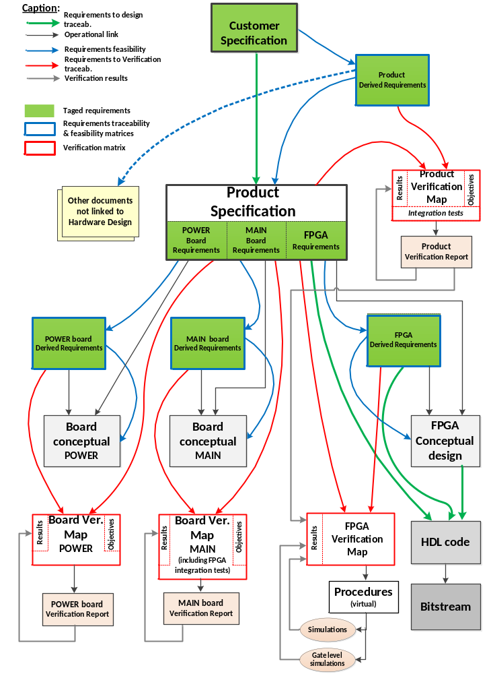

Planning Process

Typically the first process/activity described should be the planning process. It produces a set of plans and possibly applicable standards and guidelines. The plans describe the life cycle, activities, I/O, methods, environments, responsibilities, error sources and classes.

In the scope of this use case, the planning process is limited to the present document. It is assumed that some development standards are also developed.

Product Requirement Capture & Architectural Design

This process includes the following activities:
- Product functional specification capture
- Product architecture definition
- Product functional specification review

Product functional specification capture
Inputs:
Customer needs (EPS specification)
others sources (safety requirements, design choices, design constraints, best practices, assumptions…)
Supplier internal requirement capture standard

Outputs:
Product Functional Specification
Traceability matrix

Method and environment:
Exchanges with stakeholders,
Development environment for HW functional allocation.

Responsibility:
Product Engineer

Description:
- Capture and refining of Customer specification
- Identification of functions
- Traceability between functional specification and customer needs

Errors | Means of detection
specification is not correct with regards to user needs  specification is not complete with regards to user needs | Architecture activity to mature the customer needs 1.2.2  Specification review/Validation activities (including safety assessment).1.2.3

Product architecture definition
Inputs:
Customer needs,
Product Functional Specification
Internal standards
Others sources (safety requirements, design choices, design constraints, best practices, assumptions…)
Supplier internal requirement capture standard

Outputs:
Product Functional Specification including including functional allocation to FPGA
Product Derived Specification

Method and environment:
Exchanges with stakeholders, no specific environment
.

Responsibility:
Product Engineer
Customer representative
FPGA Designer
Verification eng.
Safety Eng.

Description:
- Definition of the Product architecture
- Close interaction with customer to mature expression of customer needs
- Functional decomposition and mapping
- Allocation of functions to Power & Command boards,
- Allocation of functions to FPGA, hosted on the Command board.
- Creation of Derived Requirements in Product Derived Specification (not requested by Customer Specification, from architectural definition and external sources requests)

Errors | Means of detection
specification is not correct with regards to user needs  specification is not complete with regards to user needs  Unacceptable Safety impact of added functionality and constraints (e.g. excessive complexity, non-determinist solution)  Allocation impossible to implement in FPGA  Lack of observability of FPGA content (black box) due to too high level of integration/Complexity | Specification review/Validation activities (including customer assessment). 1.2.3  Specification review/Validation activities (including safety assessment). 1.2.3  Specification review/Validation activities (including design eng. assessment) 1.2.3  Specification review/Validation activities (including verification eng. assessment) 1.2.3

Product specification review
Inputs:
Customer Specification need,
Product Functional Specification,
Product Derived Specification,
Traceability matrix (Customer Specification <-> Product Specification),

Outputs:
SoC specification review report
Safety acceptance for Derived requirement

Method and environment:
Review standard, procedure and checklist

Responsibility:
Product design Engineer
Product Verification Engineer
Safety team
Customer representative

Description:
- Independent review of the product specification with regards to the customer needs
- Ensure that customer needs are all captured by assessing a traceability matrix (customer representative is part of this review).
- Ensure that Product requirements are complete, correct, unambiguous, verifiable, and achievable based on checklist.
- Ensure that Derived requirements are identified, and Safety impact analysis accepted by Safety Engineer &/or Customer.

Errors | Means of detection
Lack of evidence of an under control review process | Use of dedicated standard and procedure for review  Person in charge of these activities have the correct skills

Note: There is a Board level Development process but not in the scope of this case study. We address only FPGA development process in this case study.

FPGA Design:

This process includes the following activities:
- FPGA Conceptual & Detailed Design
- VHDL code generation
- FPGA implementation

FPGA Conceptual & Detailed Design
Inputs:
Product specification requirements allocated to FPGA
Internal standards for FPGA

Outputs:
Conceptual & Detailed Design document (including allocation matrix),
FPGA Derived Requirement document

Method and environment:
no specific environment

Responsibility:
Design Engineer

Description:
- Architecture/Block Diagram of FPGA with allocation of Requirements to internal blocks
- Functional Description of blocks (inputs, outputs, interfaces, behavior)
- Definition of Clock Tree, Reset mechanism.
- Definition of FPGA constraints, pinout
- Definition of Testability features if necessary (e.g. test port)
- Identification of derived requirements in case of additional functionality not requested at product level (including internal interfaces and communication protocols).
- Analysis of Safety impact for FPGA derived requirements by Safety Engineer &/or Customer.
- Review of Conceptual & Detailed Design document

Errors | Means of detection
Block description is not correct with regards to covered requirements  Error in allocation  Architecture not achievable or not testable  Additional features and constraints have unacceptable safety impact | Traceability between block Diagram & Requirements  Independent Review of the outputs  Independent Review of the outputs including safety analysis of derived requirements

VHDL code generation
Inputs:
Product Specification,
Product Derived Specification,
Conceptual & Detailed Design document.

Outputs:
VHDL Code,
constraint file,
pinout file.

Method and environment:
Internal Design and coding Standards
Coding rule checker tool (qualified as per DO254)

Responsibility:
FPGA Designer.

Description:
- Manual writing of VHDL code, with embedded traceability
- Manual writing of constraint & pinout files.
➔ Could be replaced by automatic generation in case of assertion or model based approach
- Code review

Errors | Means of detection
Error on implementation of Requirements & Conceptual/Detailed Design  Error on Naming Rules defined in the Coding Standard.  Error on Design rules Defined in the Coding Standard (Clocked process, positive clock edge, resynchronization of input signal / Clock Domain crossing signal….)  Additional code not traced to a capture functionality | Perform Code review vs Requirement/CDD & Design Standard.  Perform virtual verification activities (simulation) 1.4  Could be replaced by formal analysis in case of assertion or model based approach  Perform elemental analysis (code coverage during virtual verification) 1.4

FPGA Implementation
Inputs:
VHDL code,
constraints & pinout files.

Outputs:
Netlist,
Bitstream,
Warning & Error Synthesis & P/R tools,
pinout mapping file, Usage metrics,
Static Timing Analysis (STA)
Power Consumption simulation.

Method and environment:
internal standard & FPGA Manufacturer Tools.

Responsibility:
FPGA Designer

Description:
- Generate implementation data (executable/bitstream) from the source code and constraint files.
- Generate intermediate time accurate model (object code/ netlist)
- Generate automatic reports and analysis related to timing, pinout, implementation process
- Review implementation data

Errors | Means of detection
Implementation not achieve  Implementation doesn’t fit all constraints (timing, operating conditions)  some unexpected features have been added | Use of coding and design rules to limit risk 1.3.2  Test activities 1.4.3  Review of Tool log files.  Review of STA results..

Verification of the design

This process includes the following activities :
- FPGA virtual procedure generation
- FPGA simulation
- Product verification

FPGA virtual verification procedures
Inputs:
Product specification & Product Derived Specification requirements allocated to FPGA.

Outputs:
FPGA Verification procedures (Device Virtual Verification Procedures),
Traceability data (Device Verification Matrix)
➔ automatic generation could be used through advanced verification methods (UVM..)

Method and environment:
internal Verification Standard (Verification Review guide and checklist)

Responsibility:
Design Engineer

Description:
- Selection of Verification Method by Requirement
- Manual write of Verification procedure with test scenario, including:
  - Initial conditions,
  - covered FPGA requirements
  - Objectives
  - Scenario, Pass/Failed Criteria
- Generation of Requirement Verification Coverage matrix
- Procedure review
Note: procedures are expressed in a language that can be interpreted by simulation tool and is sufficiently documented to be used as a support for a procedure review.

Errors | Means of detection
Incomplete coverage of the requirements  Foreseeable conditions not covered | Procedure review by independent peer (could be the designer)  Robustness cases to be taken in account

FPGA virtual verification
Inputs:
FPGA Verification Procedures,
VHDL Code

Outputs:
Verification results (Device Virtual Verification Results), Code Coverage Results.

Method and environment:
internal Verification Standard (Verification Review guide and checklist),
Simulation Environment Tool & scripts.

Responsibility:
FPGA Verification Engineer.

Description:
- Execution of Verification procedure with test scenario, and analysis of results, with Code Coverage enabled.
- Identification and classification of failed test results.
- Identification and justification of uncovered element.
- Review of results

Errors | Means of detection
Incomplete coverage of the requirements not detected  Foreseeable conditions not covered  Failed criteria not detected, reported, analyzed  Stress error : functions are never verified simultaneously and without sufficient set of input data (miss corner case, stress case …) | Elemental analysis report  Failed are tracked by change management process (PR)  Remaining errors (especially stress and corner cases will be detected during physical test) 1.4.3

Product test
Inputs:
Product Specification,
Product Derived Requirement document.

Outputs:
Product Verification procedures
Traceability (Product and FPGA Verification Matrix versus test procedures)
Product verification results

Method and environment:
internal Verification Standard (Verification Review guide and checklist)
Testbench,
tools
Representative environment of the product

Responsibility:
Product Verification Engineer.

Description:
- Relevance of Verification Method by Product Requirement
=> by construction FPGA requirements are a subset of product requirements (except FPGA derived requirements)

- Manual write of Verification procedure with test scenario, including:
  - Initial conditions,
  - Tracing Product requirements
  - Objectives
  - Scenario
  - Pass/Failed Criteria
- Product Requirement Verification Coverage
=> by construction FPGA requirements are a subset of product requirements (except FPGA derived requirements)
- FPGA derived Verification coverage

- Execution of Verification procedure with test scenario, and analysis of results
- Identification and classification of failed test results.
- Identification and justification of uncovered element
- Potentially Post/layout Virtual Verification if some FPGA requirements are not correctly covered (-> same activity than 8 but applied on netlist in place of source code).
- Review of procedures and results

Errors | Means of detection
Verification procedure does not fully cover the related requirements of Top Level under verification  Undetected corner cases due to insufficient representability of environment | Procedure review by independent peer  Verification result review

Artefacts examples:

<To provide actual extracts of data to clarify the key points of the proposed processes.>

